# Custom Directives

## Overview

By this point you should be able to create your own custom component as well as use a set of *builtin* Angular directives.

Now it’s time to learn how to build your own *custom* directives.

But you might be surprised to hear that you’ve *already* created a custom directive. That’s because *Components are Directives*.

Components have all the features of Directives but also have a view, that is to say they have a template and some HTML that is injected into the DOM when we use it.

Another difference is that a single HTML element can only have a *single component* associated with it. However a single element can have *multiple directives* associated with it.

Lets continue with our joke example app and create a directive which shows the punchline of the joke when the user hovers over the card.

In this section you will learn:

* How to create custom directives using the @Directive decorator.
* How directives can both listen to events and change properties of the host element they are associated with.
* How we can configure a directive so that it can take inputs when it’s defined on an element, like [aDirective]={config:'value'}

## Creating a custom directive

In this lecture we are going to create our very own custom directive.

**Learning Objectives**

* Know how to create a basic directive using the @Directive decorator.
* Know how to use selectors to associate an element with a directive based on an *attribute*.
* Know how to interact with the raw DOM element of the associated element from the directive.

**Directive decorator**

We’ll call our directive ccCardHover and we’ll attach it to the card block like so:

<div class="card card-block" ccCardHover>...</div>

 The Angular team recommends using directives as attributes, prefixed with anamespace. We’ve prefixed our directive with the namespace 'cc'.

We create directives by annotating a class with the @Directive decorator.

Lets create a class called CardHoverDirective and use the @Directive dectorator to associate this class with our attribute ccCardHover, like so:

import { Directive } from '@angular/core';

.

.

.

@Directive({

selector:"[ccCardHover]"

})

class CardHoverDirective { }

**Attribute selector**

The above code is very similar to what we would write if this was a component, the first striking difference is that *the selector is wrapped with `[]`*.

To understand why we do this we first need to understand that the selector attribute uses *CSS matching rules* to match a component/directive to a HTML element.

In CSS to match to a specific element we would just type in the name of the element, so input {… }`or `p {…}.

This is why previously when we defined the selector in the @Component directive we just wrote the *name* of the element, which matches onto an element of the same name.

If we wrote the selector as .ccCardHover, like so:

import { Directive } from '@angular/core';

.

.

.

@Directive({

selector:".ccCardHover"

})

class CardHoverDirective { }

Then this would associate the directive with any element that has a *class* of ccCardHover, like so:

<

div class="card card-block ccCardHover">...</div

>

We want to associate the directive to an element which has a certain attribute.

To do that in CSS we wrap the name of the attribute with [], and this is why the selector is called [ccCardHover].

**Directive constructor**

The next thing we do is add a constructor to our directive, like so:

import { ElementRef } from '@angular/core';

.

.

.

class CardHoverDirective {

constructor(private el: ElementRef) {

}

}

When the directive gets created Angular can inject an instance of something called ElementRef into its constructor.

How this works is called *Dependency Injection*, it’s a really important aspect of Angular and we discuss this in detail in a later section.

The ElementRef gives the directive *direct access* to the DOM element upon which it’s attached.

Let’s use it to change the background color of our card to gray.

ElementRef itself is a wrapper for the actual DOM element which we can access via the property nativeElement, like so:

el.nativeElement.style.backgroundColor = "gray";

This however assumes that our application will always be running in the environment of a browser.

Angular has been built from the ground up to work in a number of different environments, including server side via node and on a native mobile device. So the Angular team has provided a *platform independent* way of setting properties on our elements via something called a Renderer.

*script.ts*

import { Renderer } from '@angular/core';

.

.

.

class CardHoverDirective {

constructor(private el: ElementRef,

private renderer: Renderer) {

①

renderer.setElementStyle(el.nativeElement, 'backgroundColor', 'gray');

②

}

}

1. We use *Dependency Injection* (DI) to inject the renderer into our directives constructor.
2. Instead of setting the background color directly via the DOM element we do it by going through the renderer.

In the future if we wanted to render our application on a platform other than a

web browser then the Renderer calls the appropriate functions to change the background color on that platform. We are not limited to only being run in a web browser with a DOM.

Running the application now show this:

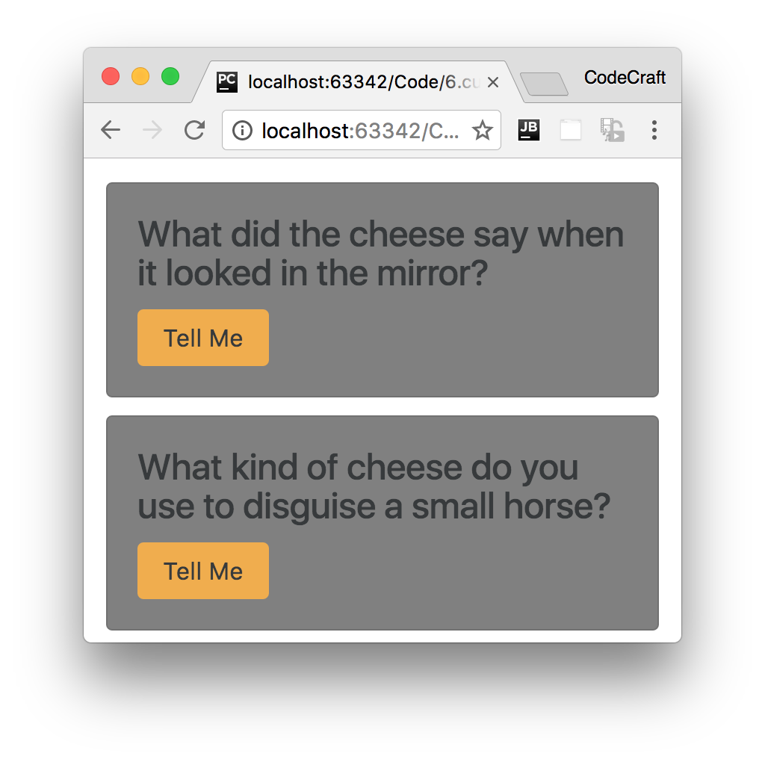

**Summary**

We create a directive by decorating a class with the @Directive decorator.

The convention is to associate a directive to an element via an *attribute selector*, that is the name of the attribute wrapped in [].

We can inject a reference to the element the directive is associated with to the constructor of the directive. Then via a renderer we can interact with and change certain properties of that element.

The above is a very basic example of a custom directive, in the next lecture we’ll show you how you can detect when the user hovers over the card and a *better* way of interacting with the host element.

**Listing**

<http://plnkr.co/edit/Aj5s1koYdGKlK5vkyGCn?p=preview>

*script.ts*

import {platformBrowserDynamic} from '@angular/platform-browser-dynamic';

import {

Component,

Directive,

Renderer,

ElementRef,

NgModule,

Input,

Output,

EventEmitter

}

from '@angular/core';

import {BrowserModule} from '@angular/platform-browser';

class Joke {

public setup: string;

public punchline: string;

public hide: boolean;

constructor(setup: string, punchline: string) {

this.setup = setup;

this.punchline = punchline;

this.hide = true;

}

toggle() {

this.hide = !this.hide;

}

}

@Directive({

selector: "[ccCardHover]"

})

class CardHoverDirective {

constructor(private el: ElementRef,

private renderer: Renderer) {

//noinspection TypeScriptUnresolvedVariable,TypeScriptUnresolvedFunction

renderer.setElementStyle(el.nativeElement, 'backgroundColor', 'gray');

}

}

@Component({

selector: 'joke',

template: `

<

div class="card card-block" ccCardHover

>

<h4 class="card-title">{{data.setup}}</h4>

<p class="card-text"

[hidden]="data.hide">{{data.punchline}}</p>

<button (click)="data.toggle()"

class="btn btn-primary">Tell Me

</button>

<

/div

>

`

})

class JokeComponent {

@Input('joke') data: Joke;

}

@Component({

selector: 'joke-list',

template: `

<

joke *ngFor="let j of jokes" [joke]="j"></joke

>

`

})

class JokeListComponent {

jokes: Joke[];

constructor() {

this.jokes = [

new Joke("What did the cheese say when it looked in the mirror?", "Hello-me

(

Halloumi)"),

new Joke("What kind of cheese do you use to disguise a small horse?", "Mask-a-

pony (Mascarpone)"),

new Joke("A kid threw a lump of cheddar at me", "I thought

‘

That

’

s not very

mature

’

"),

];

}

}

@Component({

selector: 'app',

template: `

<

joke-list></joke-list

>

`

})

class AppComponent {

}

@NgModule({

imports: [BrowserModule],

declarations: [

AppComponent,

JokeComponent,

JokeListComponent,

CardHoverDirective

],

bootstrap: [AppComponent]

})

export class AppModule {

}

platformBrowserDynamic().bootstrapModule(AppModule);